**Assignment - 6 Product Wireframe Design**

**School of Professional Studies**

[**Masters Research Project - 07 (Spring 2025)**](https://canvas.slu.edu/courses/70893)

**Professor:** [**Annamaria Szakonyi**](https://canvas.slu.edu/courses/70893/users/1379)

**Due Date: March 19th, 2025**



**Team 6**

**Group Members:**

**Amith Pitta**

**Lila Venkata Sairam Rayala**

**Mohanram Shrinivasan**

**Sai Ganesh Rao Patike Eranna**

* **Samyuktha Rani Pulagam**

### 

### **Ally Bank User Interface Wireframes (Designed using UX Pilot Tool)**

This document outlines the wireframes for the Ally Bank online banking system. It demonstrates the user interface, interactions, and navigation flow to ensure a smooth and secure banking experience.

**Login Page**

The login screen allows users to enter their credentials.

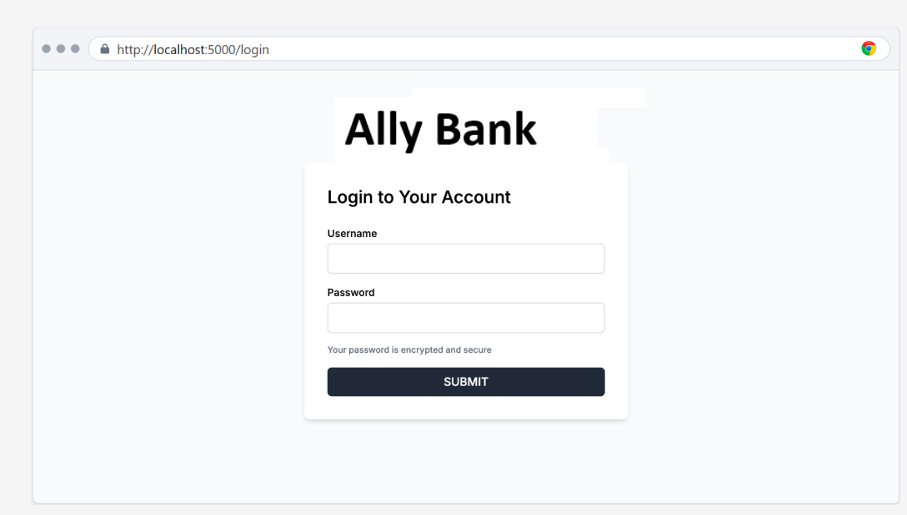



**TOTP Migration Alert**

Upon logging in, a TOTP migration alert appears, prompting users to set up TOTP authentication. allowing them to proceed or skip

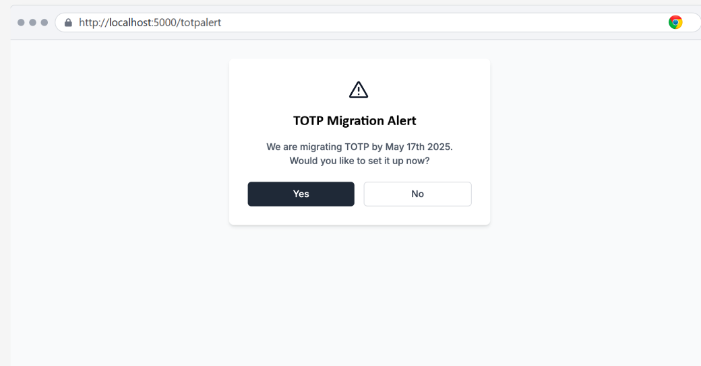

**Dashboard (Before TOTP Setup)**

If the user selects 'No' on the alert, they are redirected to the dashboard, where a reminder to set up TOTP appears.

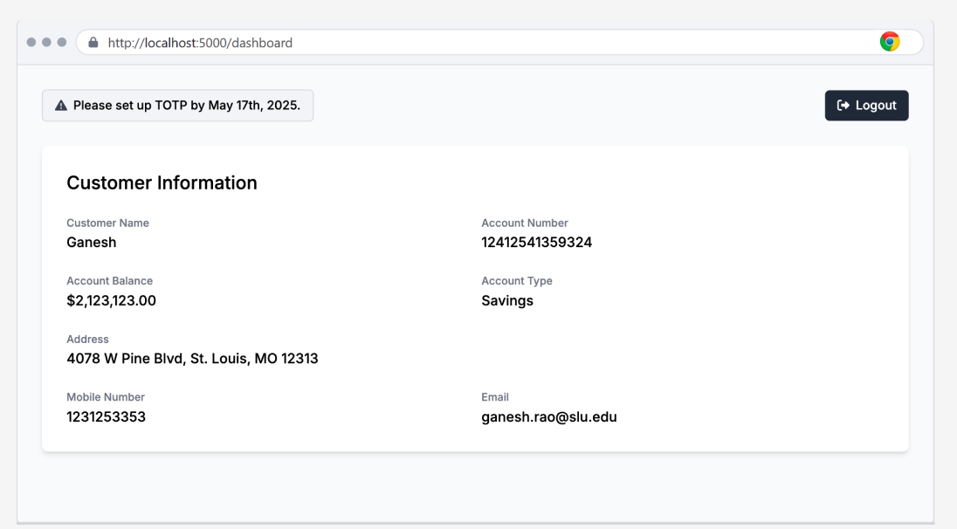

**Authenticator Setup**

If the user selects 'Yes' on the alert, they proceed to TOTP setup, where they scan a QR code to link their account with an authenticator app.

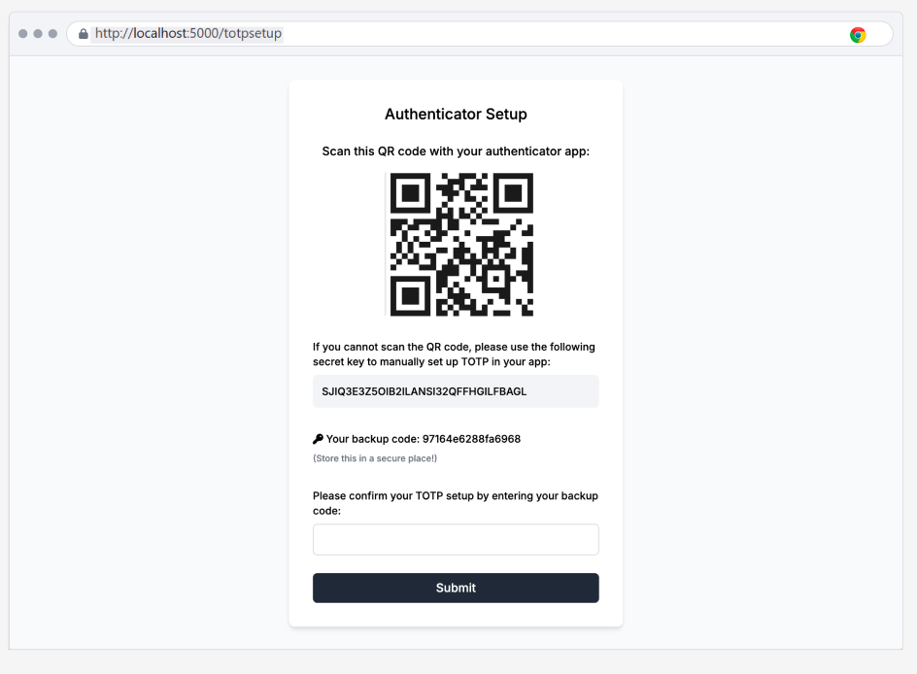

**TOTP Authentication Screen**

User Should enter the 6-digit code from the authenticator app which was installed from the above step.

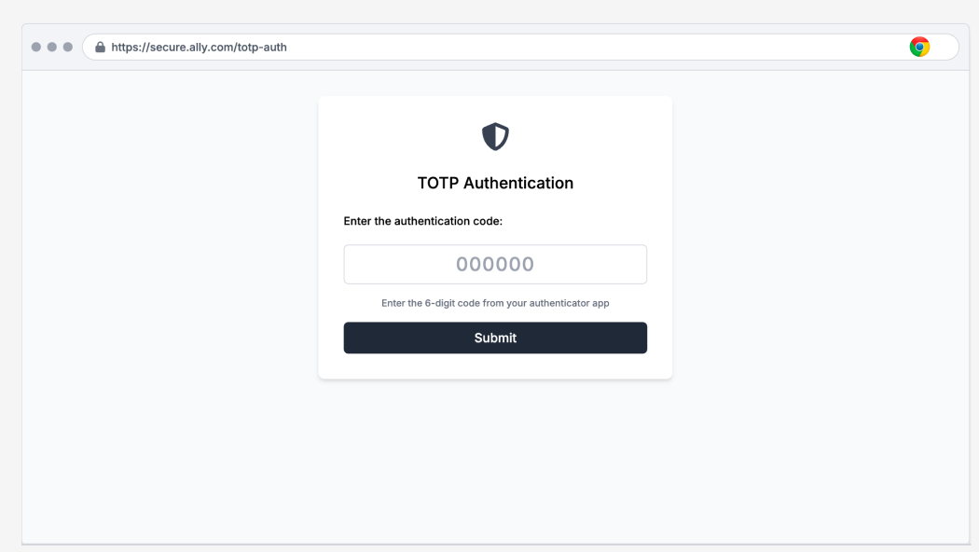



**Dashboard (Post-TOTP Setup)**

Upon successful authentication, the user accesses their dashboard.

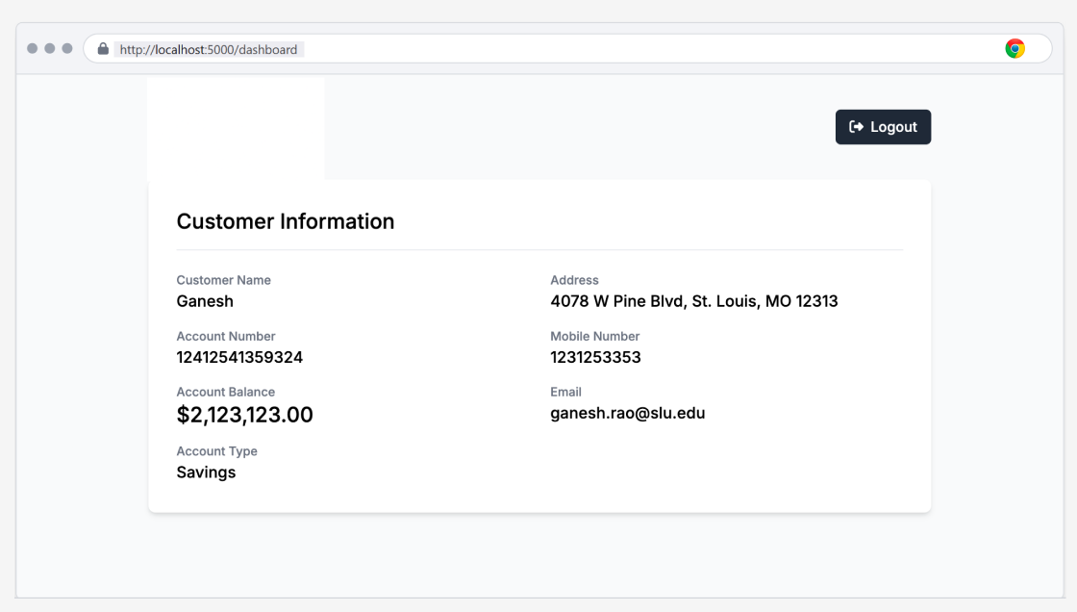

**Logout Confirmation Screen**

Users can log out, which redirects them to the logout confirmation screen.

